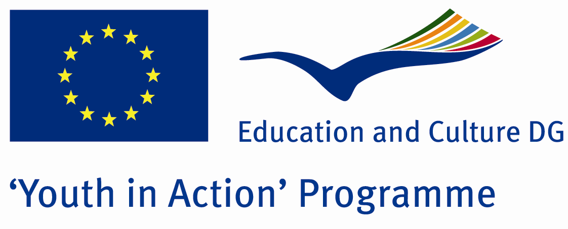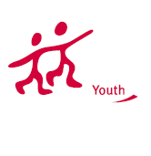

The Whisper of Nature

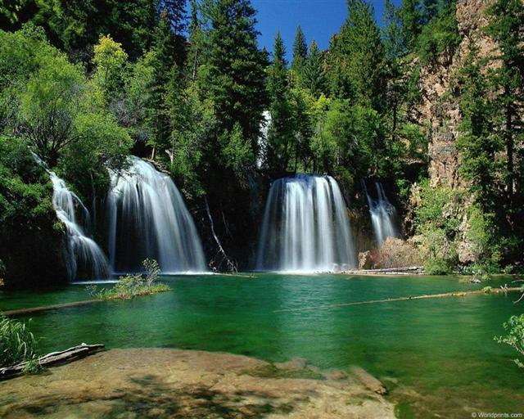

ACTION 1.1 – Youth Exchange

20-26th October, 2011

Burdur, TURKEY

Please contact directly to;
adventurerpeacepigeons@gmail.com

Project Summary;

We are all a part of nature and we live in beauty of nature. But we treat the environment badly and we do not thank you enough. Therefore we decided to do a Project about the nature. We do this Project in Burdur of which has a nature and virgin beauty. In this Project we do environmental cleanup and trekking. So we say the nature thank you.

If you want to join this project, please contact us..

Project Title; Nature and Nature

Date and Venue ; 20-26th October, 2011

Burdur, TURKEY
.

Target Group ; Municipalities, City Councils and Non-Governmental organizations,
youth groups,culture and art groups,e.t.c

Participants ; 5 people from each country (over 18 -25 ). Totally 8 countries.

Conditions ; Accommodation, board and programme costs will be financed through European Commission Youth in Action Programme (Action 4.3). Travel costs will be reimbursed in 70% (APEX Tarrifs). Organizations from all 27 EU member countries plus Liechtenstein , Norway and Iceland are eligible to take part.

Working language: English

Organizer; Adventurer Peace Pigeons

How to apply: If you are interested, please send your Part III forms to by e-mail please. in word file). Scan Part3 format is enough for application. (Fulfilled Part III which you can find in the attachment, of course signed and stamped) ..

Next step 2;
Original send via regular post to this address please:

Ertan DERİN
Fevzi Çakmak Mahallesi Tuncer Sokak No:6 PENDİK/İSTANBUL/TÜRKİYE
e-mail : adventurerpeacepigeons@gmail.com
Mobile : 0090 542 393 93 90

If you have any questions you may contact with: adventurerpeacepigeons@gmail.com

Deadline for application; until 10th May 2011.

For Further information:
Contact Person
Ertan DERİN
Fevzi Çakmak Mahallesi Tuncer Sokak No:6 PENDİK/İSTANBUL/TÜRKİYE
e-mail : adventurerpeacepigeons@gmail.com
Mobile : 0090 542 393 93 90

